**Assignment 6.4**

**Mapreduce program to find out number of males and females died in the titanic tragedy and save the output in KeyValue Output format.**

**Sample input:**

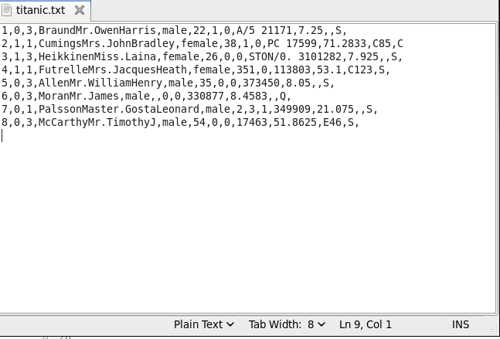

**Driver class:**

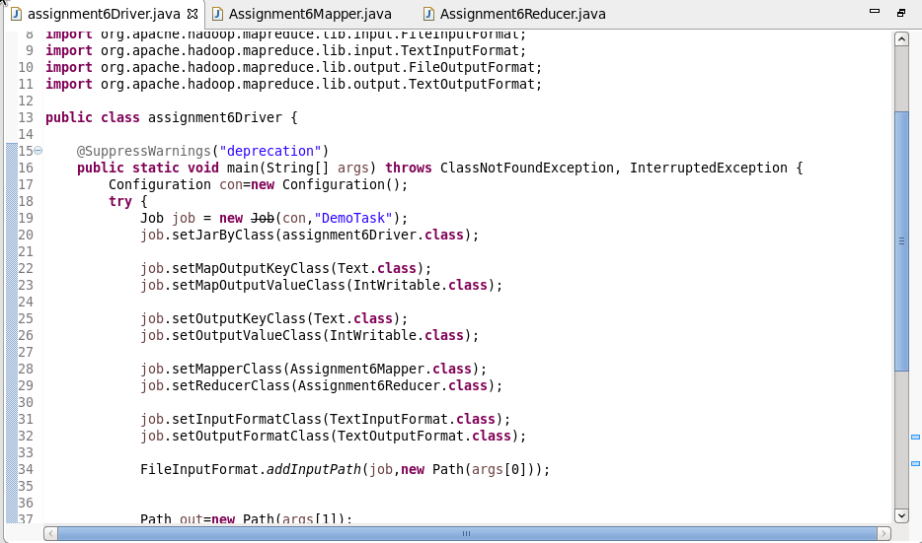

**Mapper class:**

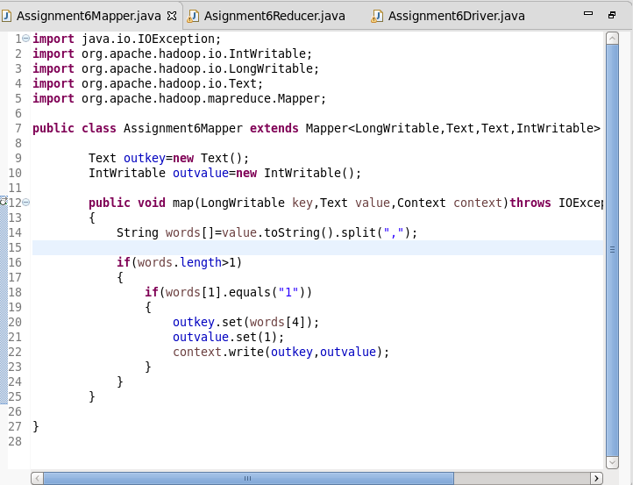

**Reducer class:**

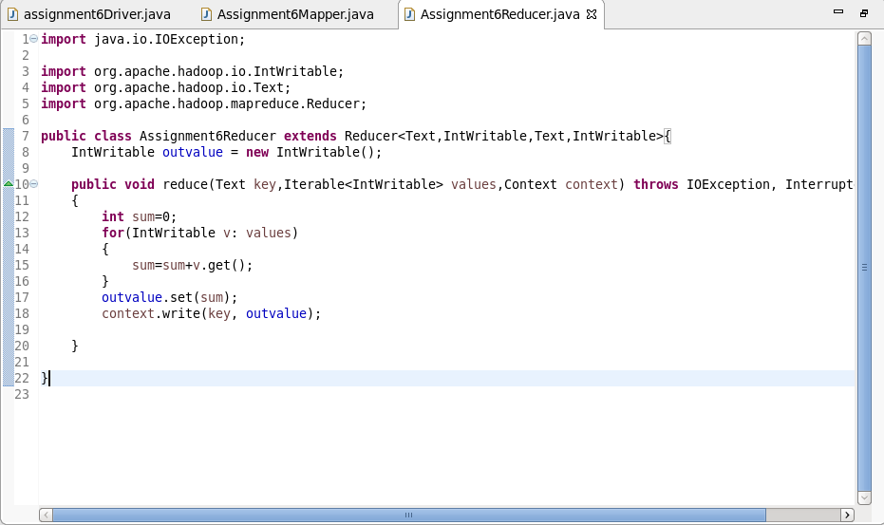

**Output:**

